**Coursera Capstone**

IBM Applied Data Science Capstone

# Cities Divided by Iron Curtain new Opportunities

# Data Section

By: Miroslav Danek

April 2021

**Prague**



vs

**Munich**

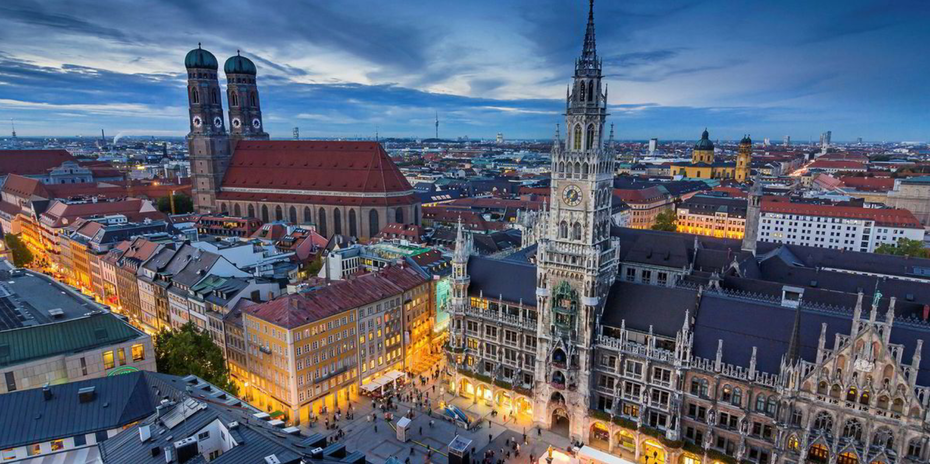

**Data**

In this project we will utilize the data from Four Square API. This data library has information about venues in world cities. We can use this data and compare the structure in both cities.

The Data should by processed in Python and stored in Pandas. The APIs uses JSON to transfer the data over the internet.

The Four-Square API needs as Input names and coordinates of the neighborhoods.

The list of neighborhoods for Munich:

[Postleitzahlen in München ⇒ Alle Postleitzahlen finden in Das Örtliche (dasoertliche.de)](https://www.dasoertliche.de/Themen/Postleitzahlen/M%C3%BCnchen.html)

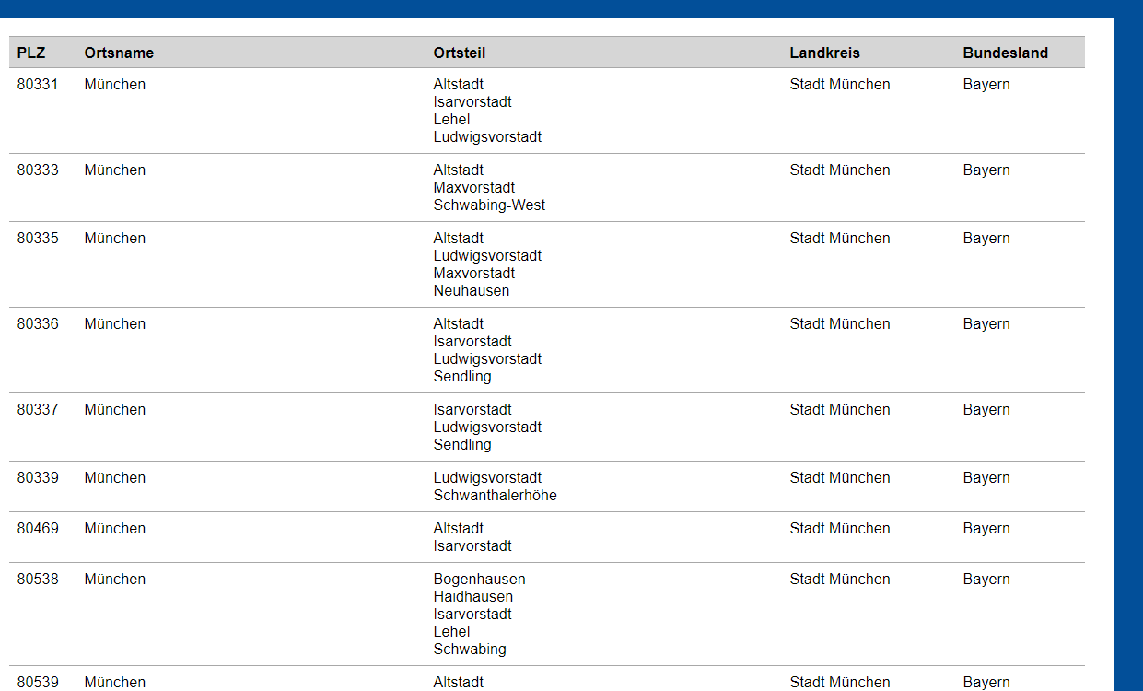

It is apparent, that in Munich has one ZIP code multiple neighborhoods.

There are 74 neighborhoods in Munich and 134 borrows in Prague. Munich and Prague don´t use the term borough as for example London.

After the list of neighborhoods is ready, the coordinates must be added. The altitude coordinate is not necessary.

The Foursquare API can deliver information about venues connected to the specific coordinates. To be able to handle them, only the 10 most frequented venues per Neiborhood will be considered.

The results will be joined in one comparative table and it will also be visualized in a bar chart.